Worksheet | Question | Graphic/Answer
1. Bass Composition | For each black bass species present, provide CPUE (bass/hr) and % of black bass catch for stock-size fish
   | Smallmouth bass | Spotted bass | Largemouth bass
  % Comp. Blk. Bass Catch
  CPUE (bass/hr)
2. Smallmouth bass growth | If smallmouth bass were aged, please provide Length @ Age data and your rating of growth on a 1(poor) - 5 (excellent) scale. | 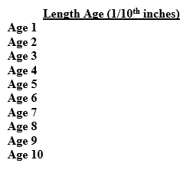Rate of Growth: _______
3. Angler access | On a 1 (poor) – 5 (excellent) scale, rate access | Rate of access: _______
4. Use | On a 1 (low) – 5 (high) scale, rate overall use. If stream use is sharply divided (such as, very high canoe use, low angling use), please provide that information as an addendum | Rate of use: _______
5. Habitat suitability | On a 1 (poor) – 5 (excellent) scale, please provide your assessment of habitat suitability for smallmouth bass. | Rating of habitat suitability: ______
6. Support | On a 1 (poor) – 5 (excellent) scale, please provide the overall rating of support for special management regulations on the candidate stream. If support was sharply divided (such as, good angler support, no support from judges/prosecutors), please provide that information as an addendum. | Rating of support: _______
7. Other management goals | If other management goals existed (trout water, Niangua darter range) which impacted consideration for special regulations, please provide. | Comment: _____
8. Geographic diversity | On a 1 (poor) – 5 (excellent) scale, please provide your rating of geographic diversity of angling opportunity, in relation to the candidate stream. In other words, if special regulations were to be placed on the candidate stream, would this provide an angling opportunity different from those nearby? Or is there another SMA nearby? | Rating of geographic diversity: ______

